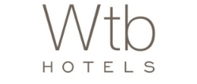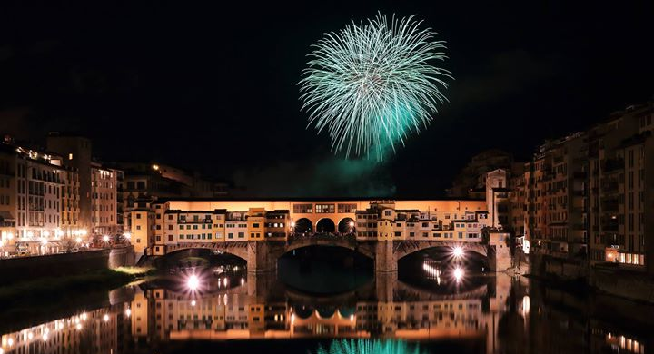
NEW YEAR'S IN FLORENCE 2017-2018
How to make the more spectacular night of the year even more amazing?
By celebrating in one of the more spectacular cities of the world!
Offer includes overnight, buffet breakfast till noon and a Bottle of Prosecco in room

Offer includes:
- Two night (or more) stay in one of our cozy rooms
- Daily buffet breakfast that on January 1st will be served till 12:00 with no supplement
- Free wifi during the entire stay
- A bottle of Prosecco Belstar Bisol DOC di Valdobbiadene in room to welcome New Year with Italian fizz!
- 10% discount at the Hotel Bar

Valid from 29th December to 1st January 2018
And valid in all our hotels
L’Orologio Venezia –L’Orologio Firenze – Santa Maria Novella – Balestri – Garibaldi Blu – Rosso 23 - Universo

No cancellations fee up to 48 hours prior
Pay at the hotel
For reservations visit www.wtbhotels.com or contact our booking dept:
Tel: +39 055 27184555 - Fax: +39 055 27184177
booking@wtbhotels.com - info@wtbhotels.com

