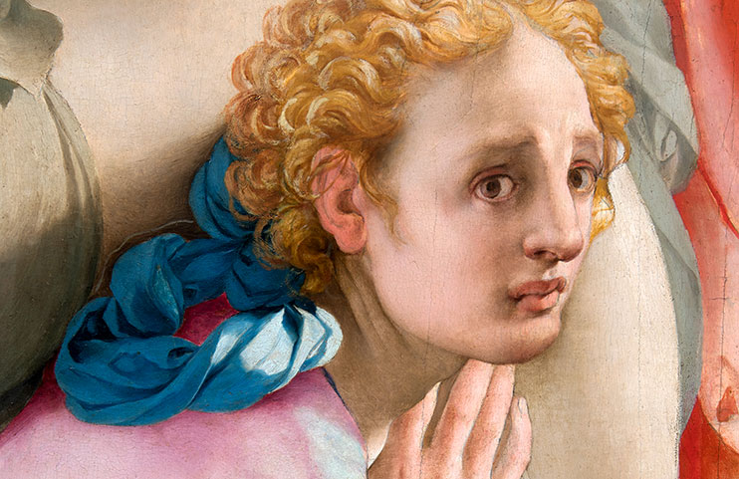
THE CINQUECENTO IN FLORENCE FROM MICHELANGELO AND PONTORMO TO GIAMBOLOGNA
From 21 September 2017 to 21 January 2018 Palazzo Strozzi will be hosting The Cinquecento in Florence. From Michelangelo and Pontormo to Giambologna, a spectacular exhibition devoted to the art of the 16th century in Florence showcasing over seventy works of art by such artists as Michelangelo, Bronzino, Giorgio Vasari, Rosso Fiorentino, Pontormo, Santi di Tito, Giambologna and Bartolomeo Ammannati.

The package includes:
- Two nights or more in one of stay in one of our welcoming rooms
- American buffet breakfast
- Tickets to the exhibition , Palazzo Strozzi
- Complimentary Wifi

Conditions:
- Minimum stay of two nights
- Rates include Vat, city tax excluded
- All cancellations and changes must be received by 12:00 noon local time, 03 days prior to arrival, or 50% of the total amount will be charged

Valid from 10th March to 23rd July 2017
Available for the following WTB hotels:
L’Orologio Firenze – Santa Maria Novella – Balestri – Garibaldi Blu

For reservations visit www.wtbhotels.com or contact our booking dept:
Tel: +39 055 27184555 - Fax: +39 055 27184177 booking@wtbhotels.com - info@wtbrhotels.com

