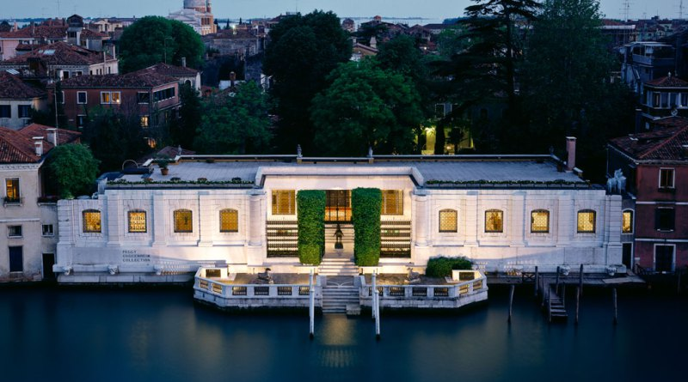
THE GUGGENHEIM EXPERIENCE
The Hotel Orologio in Venice, in a few months became a leading player of Venetian hospitality, is now offering its Guests an experience not to be missed: The Peggy Guggenheim Collection, among the most important museums in Italy for European and American art of the 20th century

Offer includes:
- 1 Ticket per person per stay for the Peggy Guggenheim Collection located in Venice, Palazzo Venier dei Leoni
- A Bottle of prosecco in the room
- American buffet breakfast
- Service and 10% of Vat
- Wi-fi connection
- Baby cot free of charge
- 0/3 years old: free (cot or bed) – sharing parent’s room
- Minimum stay of 2 nights is required

Offer is valid for stays until 15 March 2018
Rates from 310,00 € per room, per 2 night stay

For any special request and/or additional information please contact our Reservation Office at Tel: +39 055 27184555 – Fax: +39 055 27184177 - Email: BOOKING@HOTELOROLOGIOVENEZIA.COM

